Exercise 2: E-commerce Platform Search Function
Big O Notation
Big O notation measures how the running time of an algorithm grows as the input size increases. It helps in evaluating the efficiency of algorithms.
Search Scenarios
Linear Search
- Best Case: O(1) – Product found at the first position.
- Average Case: O(n) – Product found in the middle.
- Worst Case: O(n) – Product found at the last position or not found.
Binary Search
- Best Case: O(1) – Product found at the middle.
- Average Case: O(log n)
- Worst Case: O(log n)

Time Complexity Comparison
Algorithm | Best Case | Average Case | Worst Case
Linear Search | O(1) | O(n) | O(n)
Binary Search | O(1) | O(log n) | O(log n)

IMPLEMENTATION:
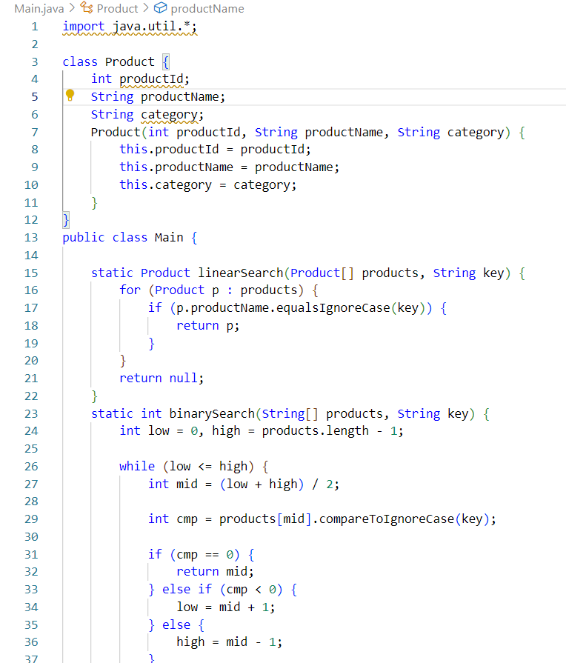

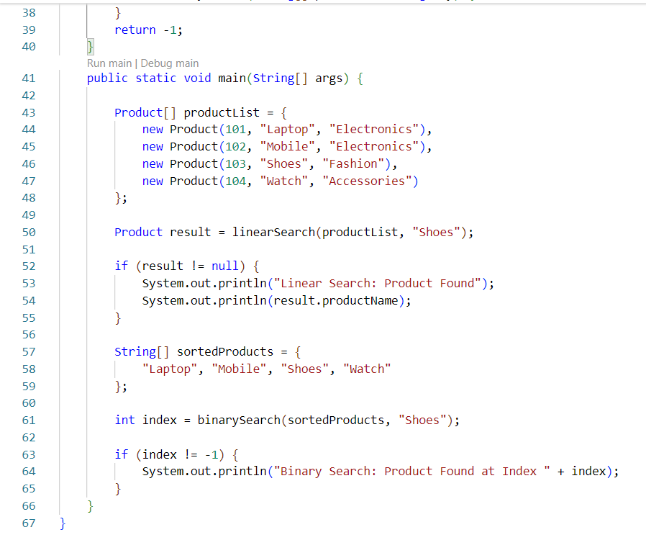
OutPut :
